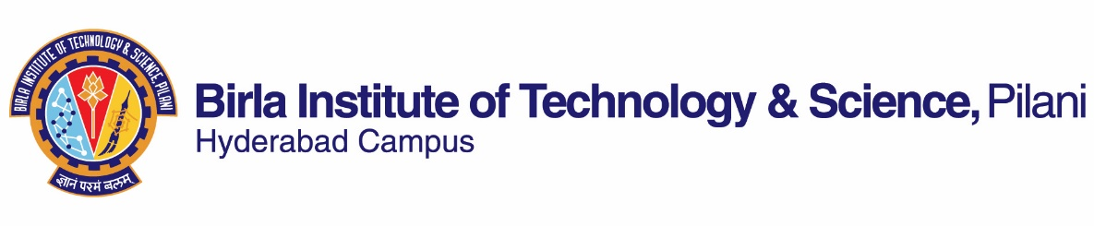
SECOND SEMESTER 2023-2024
Course Handout Part II

Date: 09.01.2024

In addition to part-I (General Handout for all courses appended to the timetable) this portion gives further specific details regarding the course.
Course No. : INSTR F343
Course Title : Industrial Instrumentation & Control
Instructor-in-charge : Joyjit Mukherjee
Instructor : Joyjit Mukherjee

- Scope and Objective of the course
This course offers study of various aspects of automatic control for industrial processes, including some recent developments in the field of process control.

- Course Description:
Introduction to process control; Elements of process loop; Controller principle; Hydraulic, pneumatic, electronic controllers; Controller tuning; Final control elements; Control loop characteristics; Complex control systems; Intelligent controllers; Programmable logic controllers; Distributed control systems; Digital control principles.

- Textbook:
Surekha Bhanot, Process Control: Principles and Applications, Oxford University press, Fourth Impression 2010

4. Reference Book:
R1: C.D. Johnson, Process Control Instrumentation Technology, Prentice Hall of India, New Delhi, 1993
R2: Liptak B.G., Process Control: Instrument Engineer’s handbook, Butterworth Heinemann
R3: Krishan Kant, Computer Based Industrial Control, Prentice Hall of India, New Delhi, 1997
R4: Stephanopoulos George, Chemical Process Control, Prentice Hall of India
R5: Ogata K., Modern Control Engineering, Pearson Education Asia

- Course plan

Lecture  No. | Learning Objective | Topics to be covered | Chapter in the Textbook
1,2 | To appreciate the needs, objectives of process control | Basic Control loop, variables, requirements, aims, parameters, dynamics of the process | T-CH1 R4(1.9)
3 | To understand the dynamics of processes | Terms, concepts used in process dynamics | T-CH2
4 | To understand/review the concepts of Transfer function | Transfer functions, block diagram and signal flow representation | R5-CH4
5 | To understand need and concept of mathematical modeling | Model of lumped and distributed parameter systems | T-CH2, R3 –CH11, R5-CH2,3 &4
6,7 | To understand steady state and transient analysis | Transient and steady state analysis of first order, second order and higher order systems and numerical to highlight concepts | R5-CH5
8 | To understand different controller modes | On-off, on-off with neutral zone | T-CH3 , R4(9), R3 – CH1
9,10,11 | To understand different controller modes | Proportional, Integral, derivative, PI, PD, PID | T-CH3, R4(9), R3 – CH1
12,13 | To learn dynamic behavior of feedback-controlled systems | Effect on dynamic behavior of process with different controller modes in closed loop with | T-CH4, R4(14)
14,15 | To learn about controller tuning | Ziegler, Cohen-Coon, Integral performance | T-CH4, R4
16 | To learn about DDC loop | Sampling and reconstruction, DDC structure, position & velocity algorithm | T-CH5
17 | To realize controller modes in pneumatic controllers | Controller modes in Pneumatic controllers | T-CH6, R5 (4.3)
18 | To realize controller modes in hydraulic controllers | Controller modes in Hydraulic controllers | T-CH6, R5 (4.4)
19 | To realize controller modes in electronic controllers | Controller modes in electronic controllers | T- CH7, R1(10.3)
20,21 | To learn the evolution, hardware of Programmable Logic Controllers | PLC vs relay Logic, PLC vs PCs, hardware components | T-CH13, R3(5), R2
22,23 | To learn ladder diagram programming | Ladder diagram, selection of PLCs | T-CH13, R3(5), R2
24 | To learn application of AI techniques in process control | Role of AI | T-CH14, R3(13), R2
25,26 | To learn ES structure & Application | ES structure, Design & Applications | T-CH15, R3(13)
27,28 | To learn concept & applications of FLC | Fuzzy controllers | T-CH17, R3(13), R2
29 | To learn about different final control elements | Functions of control valves, Types of control valves, actuators | T-CH8, R3 –CH4
30 | To understand P&I diagrams | Draw P&I diagrams | T-CH9
31,32 | To understand complex control schemes | Cascade control, Ratio control, | T-CH10, R4(20, 21)
33,34 | To understand complex control schemes | Feedforward, Adaptive control, Inferential, Model reference adaptive control, Self tuning regulator | T-CH10, R4 (21)
35,36 | To understand complex control schemes | Override, Auctioneering, Split Range | T1-CH11, R4(22)
37,38 | To understand interaction and decoupling of control loops | Design of cross controllers and selection of loops using RGA | T-CH12, R4(24)
39,40 | To understand distributed digital control systems | History, functional requirements, system architecture, configuration | T-CH18, R3(6), R2

- Evaluation Scheme
Components | Duration | Weightage | Marks | Date & Time | Nature of Component
Midsem | 90 minutes | 30 % | 60 | 14/03 - 9.30 - 11.00AM | Closed Book
Quizzes | To be announced | 15% | 30 | To be announced | Closed Book
Term Paper / Assignments | - | 15% | 30 | Take Home | Open Book
Comprehensive | 180 minutes | 40 % (10 % Open book and 30% Closed book) | 80 | 13/05 FN | 10 % Open book and 30% Closed book
Total |  | 100% | 200

- Chamber Consultation Hour: To be announced in the class.
- Course Notices: Notices will be displayed in CMS.
- Make-up Examination: Make-up will be given on extremely genuine grounds only for those receiving prior approval. No make up for quizzes
- Academic Honesty and Integrity Policy: Academic honesty and integrity are to be maintained by all the students throughout the semester and no type of academic dishonesty is acceptable.

Joyjit Mukherjee
Instructor-in-charge
INSTR F343

